# Requirements – Student #5

Please, fill in the following form, make sure that you have ticked the requirements that you consider fulfilled, save this document, **and attach it in its original format (.docx)** to every deliverable. Regarding your ID, please keep only four random digits and mask the others using an asterisk. **Please, note that this document must be edited with the desktop version of Word since the web version does not properly support forms.** Attaching this document entails that you are the authors of the work delivered, you have not cheated in any way, and you have read and understood the information delivered regarding the subject, with a special emphasis on the methodological guidelines and how your work is going to be graded. Make sure that your project works well with the latest version of the development framework.

|  |
| --- |
| **Group:** C1.027 |
| **Repository:** https://github.com/DP2-C1-027/AirNav-Logistics |
| **Student #2**  **ID Number:** 77*3**0*K  **UVUS:**  HHV4884  **Name:**  Campos Díez, Lucía  **Roles:**  Developer, Tester |
| **Date:** Seville 02 19, 2025 |

# MANDATORY Deliverable D01: introduction

## Information requirements

Intentionally blank.

## Functional requirements

1. Modify the anonymous menu so that it shows an option that takes the browser to the home page of your favourite web site. The title must read as follows: “〈id-number〉: 〈surname〉, 〈name〉”, where “〈id-number〉” denotes your DNI, NIE, or passport number, “〈surname〉” denotes your surname/s, and “〈name〉” denotes your name/s.

X

## Non-functional requirements

Intentionally blank.

## Testing requirements

Intentionally blank.

## Managerial requirements

1. Provide a link to your planning dashboard in GitHub to review the tasks, their current status, and your schedule.

X

# MANDATORY Deliverable D02: data models

## Information requirements

1. The **technicians** care of aircraft maintenance by conducting regular inspections, performing repairs, and carrying out other maintenance tasks. The system must store the following data about them: a **license number** (unique, pattern "^[A-Z]{2-3}\d{6}$"), a **phone number** (pattern "^\+?\d{6,15}$"), their **specialisation** (up to 50 characters), whether they have passed their **annual health test** or not, and their **years of experience**. Optionally, the system may store their **certifications** (up to 255 characters).

X ¿Por qué se ha puesto la anotación de @ValidIdentifier en la cabecera de la clase en vez de en el atributo correspondiente? Lo habitual es definir tres anotaciones por cada atributo, una de ellas específica para validar los valores asignados al atributo concreto:

Para poder solucionar este problema he optado por hacer un validador únicamente para el realm de technician (@ValidTechnician):

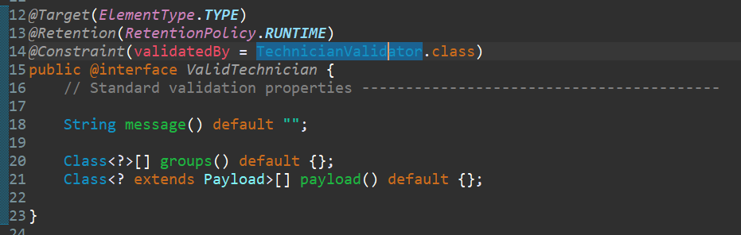

Y movido la validación del código (validIdentifier) al atributo en concreto:

1. **Maintenance records** are comprehensive records of activities performed on a given **aircraft** throughout its operational life. The system must store the following data about them: the **moment** when a maintenance takes place, its **status** ("PENDING", "IN PROGRESS", "COMPLETED"), the next **inspection due date**, an **estimated cost**, and some optional **notes** (up to 255 characters).

X En el material de clase se explica que sólo una anotación de persistencia. Hay tres, @Automapped, @Column (unique = true) y @Temporal. Se debe escoger para cada atributo sólo una de ellas:

He reducido las validaciones manteniendo aquellas que eran necesarias para poder cumplir los requisites del cliente y, a la vez, siguiendo las pautas del material otorgado en la asignatura:

1. **Maintenance records** rely on **tasks**. A task is a specific predefined operational duty carried out by a **technician** on **aircrafts**. The system must store the following data about tasks: their **type** ("MAINTENANCE", "INSPECTION", "REPAIR", "SYSTEM CHECK"), a **description** (limited to 255 characters), a **priority** (ranging from 0 to 10), and an **estimated duration** (in hours).

X

## Functional requirements

Intentionally blank.

## Non-functional requirements

Intentionally blank.

## Testing requirements

1. Produce assorted sample data to test your application informally. The data must include two **technician** accounts with credentials “**technician1**/ **technician1**” and “**technician2**/ **technician2**”. Create an additional technician account with credentials “**technician3/ technician3”** that represents a technician with no data, but his or her profile.

X

## Managerial requirements

1. Provide a link to your planning dashboard in GitHub to review the tasks, their current status, and your schedule.

X

# MANDATORY Deliverable D03: implementing features

## Information requirements

Intentionally blank.

## Functional requirements

1. Operations by **technicians** on **maintenance records**:

* List their maintenance records.
* Show the details of the maintenance records, including the tasks involved.
* Create, update, and publish maintenance records. Please, note that to publish a maintenance record, it cannot have any unpublished tasks and should have at least one published task.

El atributo "notes" de la entidad "MaintenanceRecord" es opcional. Sin embargo, cuando estoy creando un objeto de esa entidad, me obliga a rellenar ese campo del formulario:

El requisito no está correctamente implementado ya que un maintenance record puede tener tareas de cualquier technician. El sistema implementado sólo permite añadir tareas cuyo propietario coincide con el propietario del maintenance record. A continuación, se muestra como un technician con dos maintenance records sólo puede añadir a éstos la única tarea que tiene el technician cuando hay muchas más tareas publicadas en la BD.

Para solucionar el problema de la validación de las notas recurrí a un validador que permitiera al cliente dejar el campo en blanco.

Respecto al requisito no implementado correctamente:



Ahora el técnico tiene la opción de coger todas sus tareas y todas las tareas que los demás técnicos hayan publicado en la BD.

1. Operations by **technicians** on **tasks**:

* List their tasks and show their details.
* Create, update, delete, and publish tasks. Note that published tasks cannot be updated or deleted.

Hay errores de validación:

He publicado una task, he creado un maintenance record con solo esa task, he publicado la task y después he publicado el maintenance record. Finalmente he hecho un "show" del maintenance record y he visitado la lista de tareas del mismo. He hecho clic en la única que había, y he obtenido la siguiente excepción:

Los errores de validación se han solucionado de tal manera que solo saldrán dos posibles mensajes de error en el caso de publicación de un record: no tiene ninguna task asociada o hay task que están asociadas a él y que no están publicadas:

También he hecho cambios en el authorise del show de las tasks para que no ocurriera el error de Access is not authorise:

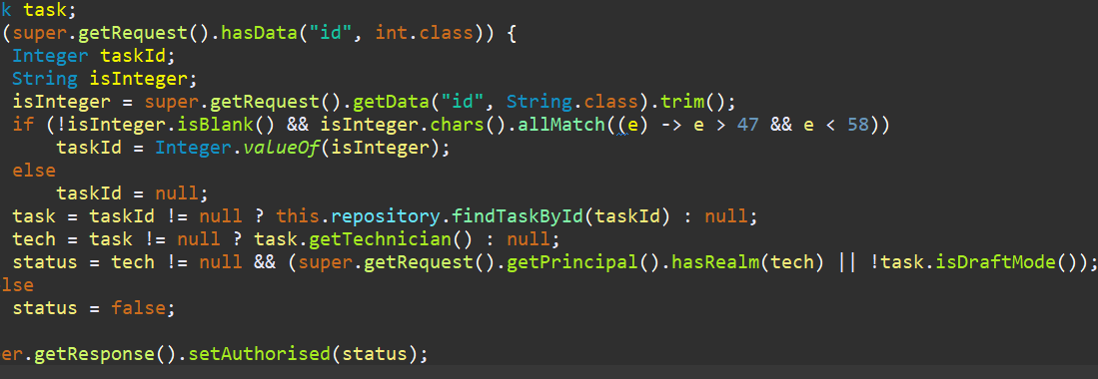

Ahora se pueden ver aquellas de las que son propietarios o están publicadas en la BD.

## Non-functional requirements

Intentionally blank.

## Testing requirements

Intentionally blank.

## Managerial requirements

1. Provide a link to your planning dashboard in GitHub to review the tasks, their current status, and your schedule.

X

# MANDATORY Deliverable D04: formal testing

## Information requirements

1. Create appropriate indices for your entities, if required.

X

## Functional requirements

Intentionally blank.

## Non-functional requirements

Intentionally blank.

## Testing requirements

1. Produce a test suite for Requirements #8 and #9.

X

## Managerial requirements

1. Provide a link to your planning dashboard in GitHub to review the tasks, their current status, and your schedule.

X

1. Produce a testing report.

X

# SUPPLEMENTARY I Deliverable D01: introduction

## Information requirements

Intentionally blank.

## Functional requirements

Intentionally blank.

## Non-functional requirements

Intentionally blank.

## Testing requirements

Intentionally blank.

## Managerial requirements

Intentionally blank.

# SUPPLEMENTARY I Deliverable D02: data models

## Information requirements

1. The system must handle **technician dashboards** with the following **indicators**:

* The number of maintenance records grouped by their status.
* The maintenance record with the nearest inspection due date, provided that he or she is involved in any tasks that need to be performed as part of that maintenance.
* The top five aircrafts with higher number of tasks in their maintenance records.
* The average, minimum, maximum, and standard deviation of the estimated cost of their maintenance records in the last year.
* The average, minimum, maximum, and standard deviation of the estimated duration of the tasks in which he or she is involved.

X

## Functional requirements

Intentionally blank.

## Non-functional requirements

Intentionally blank.

## Testing requirements

Intentionally blank.

## Managerial requirements

1. Produce a UML domain model regarding the information requirements in your project.

X

# SUPPLEMENTARY I Deliverable D03: implementing features

## Information requirements

Intentionally blank.

## Functional requirements

1. Operations by **anonymous principals** on **user accounts**:

* Sign up to the system and become a technician.

X

1. Operations by **technicians** on **user accounts**:

* Update their profiles.

X

1. Operations by **administrators** on **maintenance records**:

* List the maintenance records in the system that are published.
* Show the details of the maintenance records (including the tasks involved).

X

1. Operations by **technicians** on **dashboards**:

* Show their dashboards.

## Non-functional requirements

Intentionally blank.

## Testing requirements

Intentionally blank.

## Managerial requirements

1. Provide a link to a video in which you informally test requirement #8 and #9. Videos should not exceed 10 minutes in length and must be stored at the USE's facilities.

# SUPPLEMENTARY I Deliverable D04: formal testing

## Information requirements

Intentionally blank.

## Functional requirements

Intentionally blank.

## Non-functional requirements

Intentionally blank.

## Testing requirements

1. Perform five mutations in your code and report on the results.

## Managerial requirements

1. Produce a lint report.

# SUPPLEMENTARY II Deliverable D01: introduction

## Information requirements

Intentionally blank.

## Functional requirements

Intentionally blank.

## Non-functional requirements

Intentionally blank.

## Testing requirements

Intentionally blank.

## Managerial requirements

1. Produce an analysis report.

X

1. Produce a planning and progress report.

X

# SUPPLEMENTARY II Deliverable D02: data models

## Information requirements

1. The system is required to have a notice board to advertise **courses** for technicians. A web service must be used to populate this entity with information about courses. Thus, the exact data to store depends on the chosen service, and it is the students' responsibility to define them accordingly. It is also the students’ responsibility to find the appropriate service; no implicit or explicit liabilities shall be covered by the University of Seville or their individual affiliates if the students hire pay-per-use services! The students are strongly advised to ensure that the service they choose is free of charge.

X

## Functional requirements

Intentionally blank.

## Non-functional requirements

Intentionally blank.

## Testing requirements

Intentionally blank.

## Managerial requirements

1. Produce an analysis report.

X

1. Produce a planning and progress report.

X

# SUPPLEMENTARY II Deliverable D03: implementing features

## Information requirements

Intentionally blank.

## Functional requirements

1. Operations by **technicians** on **courses**:

* List the course available and show their details.

1. Operations by **administrators** on **courses**:

* Populate the database with courses data.

## Non-functional requirements

Intentionally blank.

## Testing requirements

Intentionally blank.

## Managerial requirements

1. Produce an analysis report.

1. Produce a planning and progress report.

# SUPPLEMENTARY II Deliverable D04: formal testing

## Information requirements

Intentionally blank.

## Functional requirements

Intentionally blank.

## Non-functional requirements

Intentionally blank.

## Testing requirements

1. Produce as a complete test suite as possible for Requirement #29 ensuring that the web service is properly mocked.

## Managerial requirements

1. Produce an analysis report.

X

1. Produce a planning and progress report.

X